This document gives the screen shots of various options tested (on IE 7) for the defect Omiga00000050 (Vertex Ref: 12).

High contrast option is selected from accessibility menu in ‘Control Panel’. The navigation buttons (OK, Cancel) do not appear. But, while moving the mouse pointer across, the pointer is changed (to Hand symbol) and lets the button to be clicked. Changing of the mouse cursor cannot be captured in a screen shot. (Fig1.). The behaviour is exactly the same on IE 6.0

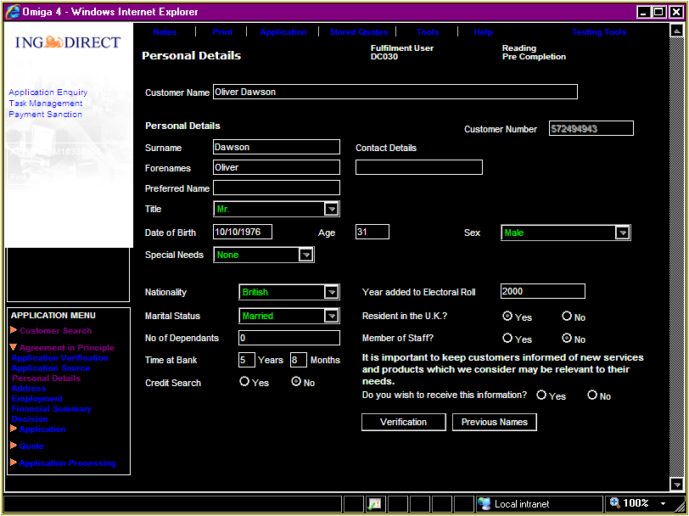 (Fig. 1)

Choosing the large fonts in accessibility options, would not increase the size of the fonts in Omiga. You can notice that the scroll bars appeared in the screen (Fig. 2). Even the other applications like MS – Word did not increase the size of the fonts – does it mean the problem is just within Omiga but at Windows level. If the screen is view on IE 6.0, after the same settings are applied, the size of the text on Omiga screens has changed. But, the text is wrapped and overlapping on another text. This is quite un-readable as shown in Fig. 2.1.

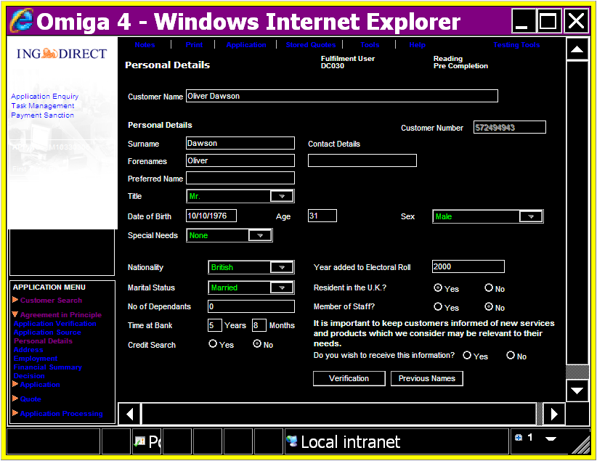 (Fig. 2)
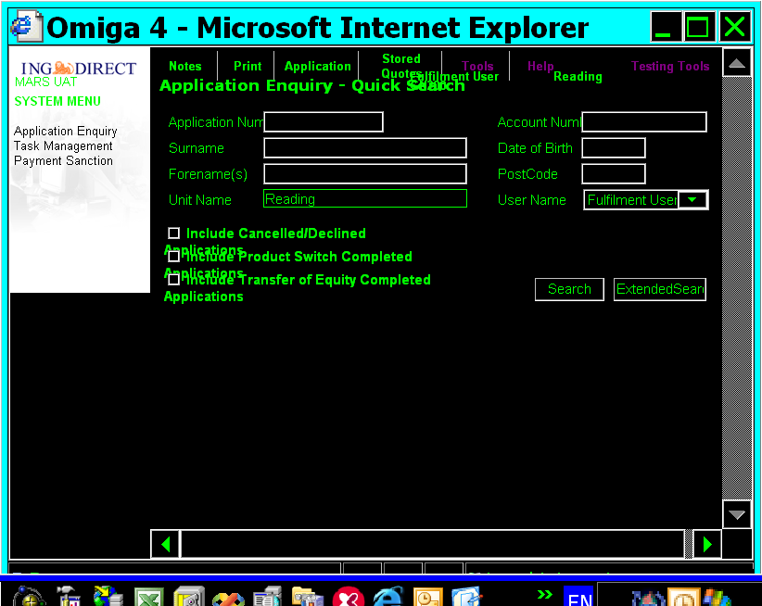 (Fig 2.1)

By zooming-in using option on browser (bottom – right hand side) or by using scroll wheel on mouse and ctrl key, you can see that fonts are enlarged (Fig. 3). Zooming-in is not an option on IE 6.0

However, all the information can be viewed by scrolling across the screen (Fig. 4).

In all cases the OK and Cancel buttons are not visible. When mouse pointer is rolled over the button, the cursor changes and allows clicking.

Fig. 5: Change of font size in accessibility options or zooming in using the mouse (and ctrl key) does not have any affect on a pop-up window. We cannot zoom in any other way for this window. The size of the fonts on border (set by windows) has changed.

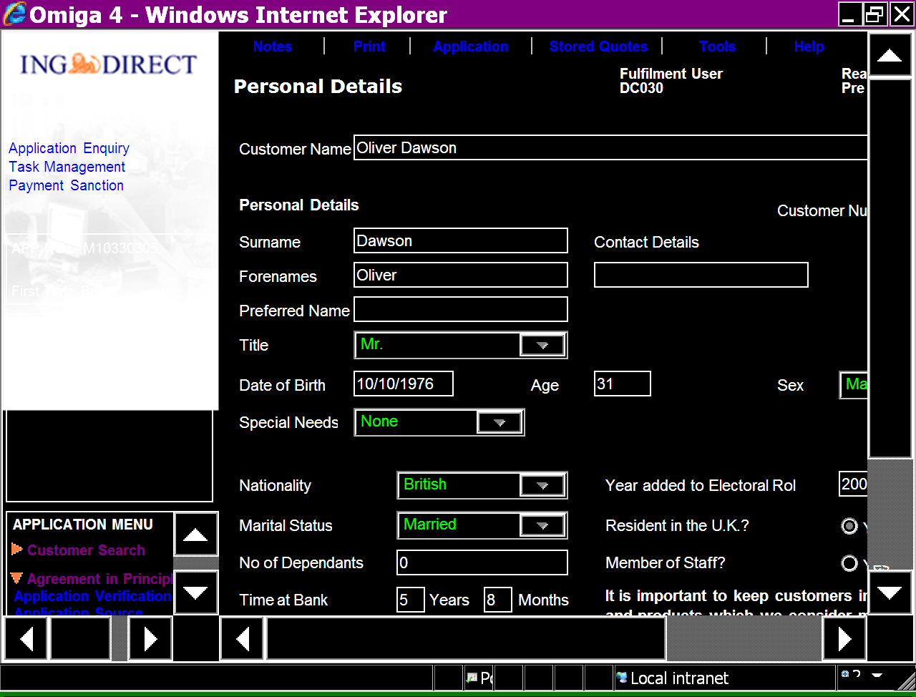 (Fig 3)
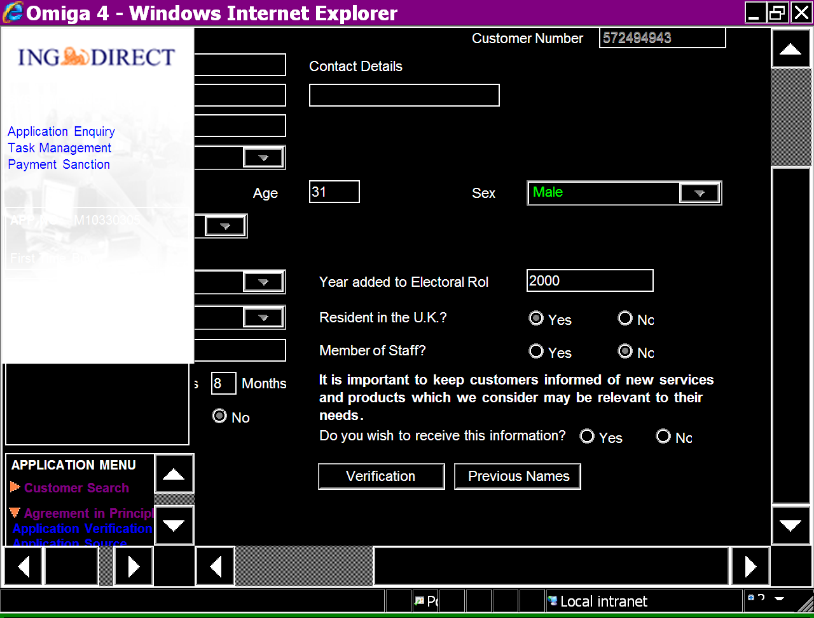 (Fig 4)
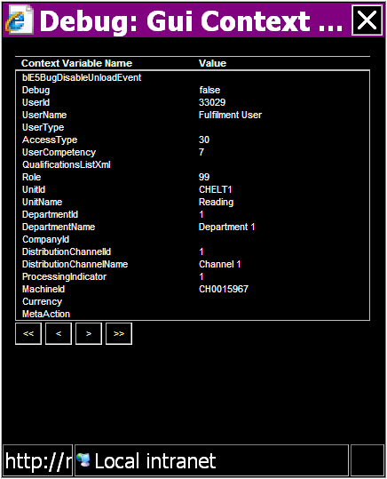 (Fig 5)
Changing the Text Size via browser option (via Page -> Text Size) does not seem to have any affect on the size of the fonts in Omiga. But the fonts rendered by windows (on the border of the browser) changed accordingly. The behaviour is exactly the same on IE 6.0.

Fig. 6 depicts ‘Logon’ screen with Text Size set to Largest.

Fig. 7 depicts ‘Logon’ screen with Text Size set to Smallest.

Text size changes via setting on browser can not be done for pop-up window.
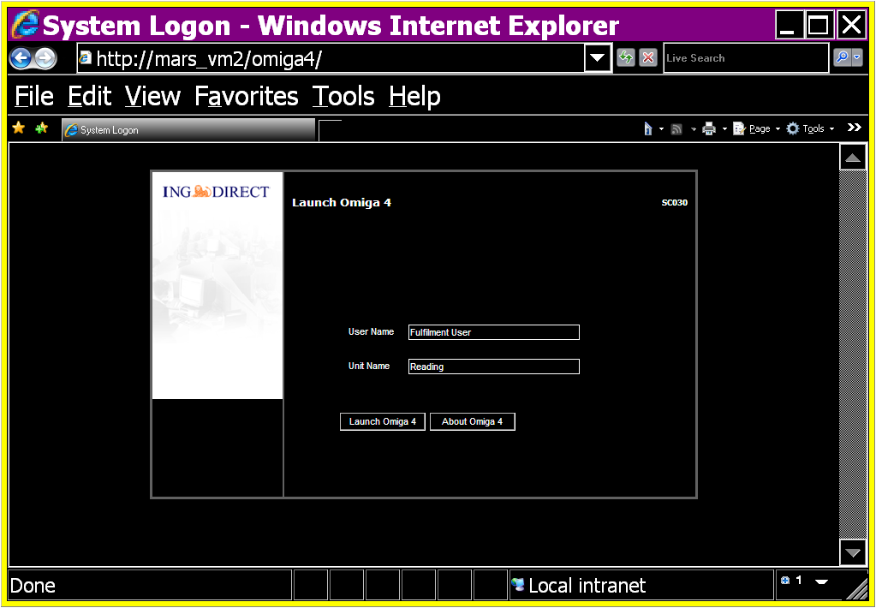 (Fig. 6)
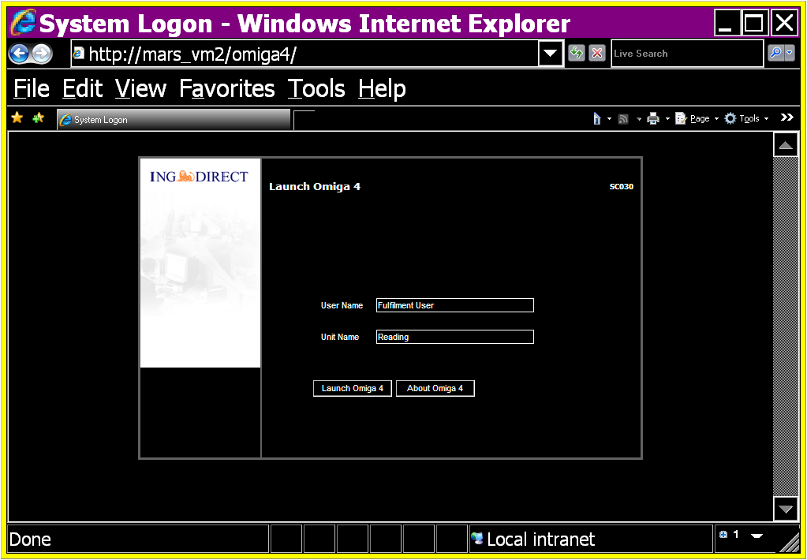 (Fig. 7)
Changing the font size and colour scheme setting via accessibility options, has reflected in Display ->Appearance (Colour scheme and font size). The affect of changing settings via Display->Appearance on Omiga is also same as that changing via accessibility options.

Fig 8: Font size changed to Extra Large. This setting does not have any affect on Omiga application.
Fig 9: A pop-up window on Omiga after Font size changed to Extra Large via in Display ->Appearance
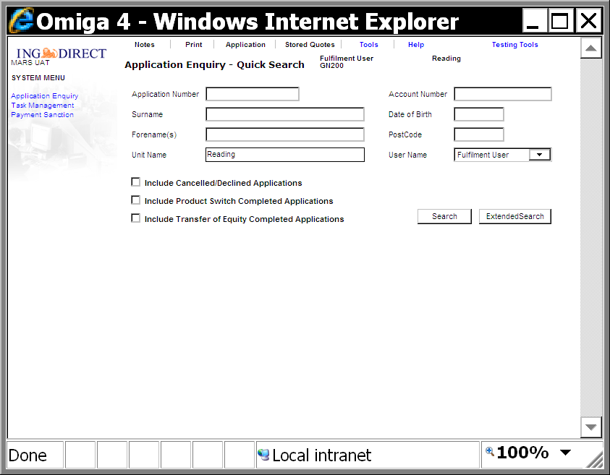 (Fig. 8)
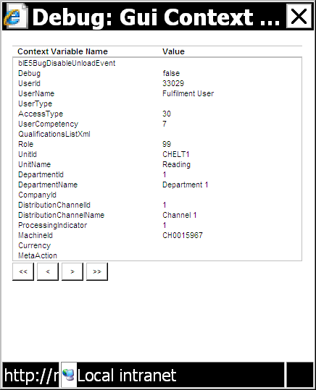 (Fig. 9)
We have looked into this area of the system earlier but, did not attempt to do because it is too much of work.

